**RESOLVING RESENTMENT**:

<http://www.saint-clements.com>

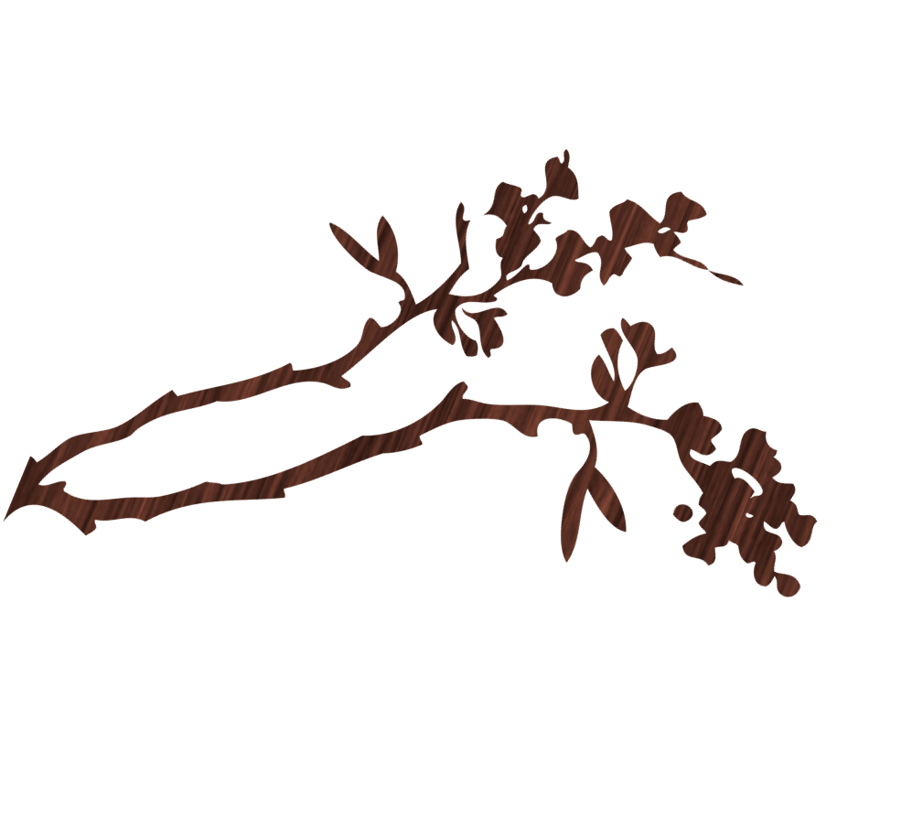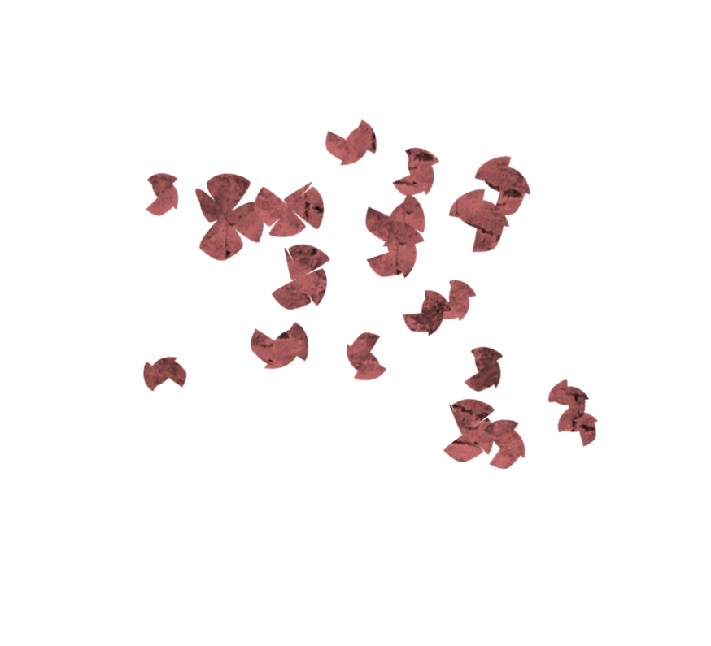

RETREAT FOR PERSONAL HEALING

September 10, 2016, Saturday, 9:00 a.m. to 3:30 p.m.

**St. clement’s episcopal church**

**2376 Zinfandel Drive, Rancho Cordova, ca 95670**

This day-long retreat is for anyone who has been carrying the burden of pain or resentment for past hurts, and is finally ready to let go and be free. Led by the Rev Dr Rob Voyle, Episcopal Priest and Clinical Psychologist. For more information and to register, go to:

<http://www.appreciativeway.com/training/forgive-retreat.cfm>

**What You Will Learn**

* Practical ways of being a compassionate presence in the world.
* The nature of resentment and the nature of forgiveness.
* **How to personally move from resentment to forgiveness.**
* Ways to protect yourself emotionally from those who intimidate you.
* To use the forgiveness strategies to achieve self-forgiveness.
* What resentment, forgiveness, and reconciliation are and what they are not.

Retreat Fee (includes lunch): $75 on or before August 10. Bring a friend and you both save $15.

**"Wow! 45 years of resentment its gone! Wow!" comment by retreat participant**