**Live Music**

**St. Patrick’s Day Celebration**

Family Friendly

**Saturday, March 18th, 2023**

12:00 Noon to 8:00 PM

**Strad Meadery**

2539 Mercantile Dr, Rancho Cordova

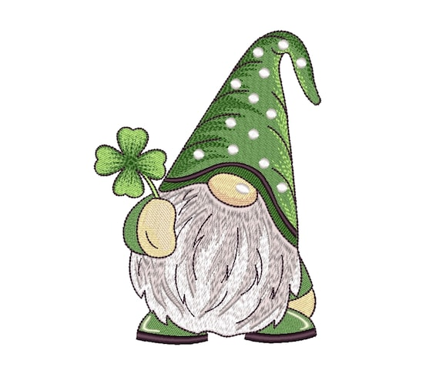

**One Eyed Reillys**

**Unquiet Grave**

**Celtic Charms**

**Face Painting**

**Food & Vendors**