CITY OF RANCHO CORDOVA
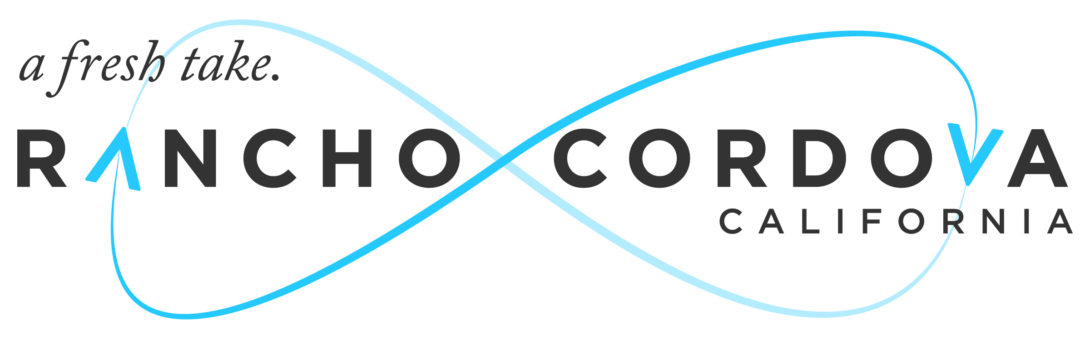

CONCURRENT MEETING

RANCHO CORDOVA CITY COUNCIL/
SUCCCESSOR AGENCY TO THE FORMER COMMUNITY
REDEVELOPMENT AGENCY (CRA)/
RANCHO CORDOVA FINANCING CORPORATION (RCFC)

2729 Prospect Park Drive, Rancho Cordova, CA 95670
5:30 P.M. – Special Meeting

Tuesday, June 28, 2016

NOTICE OF CANCELLATION

The Tuesday, June 28, 2016 Special Meeting/Work Session of the City Council/Successor Agency to the Former Community Redevelopment Agency (CRA)/Rancho Cordova Financing Corporation (RCFC) is cancelled.

Certification of Posting of MEETING CANCELLATION

I, Mindy Cuppy, City Clerk for the City of Rancho Cordova, declare that the foregoing cancellation notice for the June 28, 2016 Special Meeting of the Rancho Cordova City Council/Successor Agency to the CRA/RCFC was posted and available for review on Friday, June 24, 2016 at City Hall of the City of Rancho Cordova, 2729 Prospect Park Drive, Rancho Cordova, California, 95670.

Signed this 24th day of June, 2016 at Rancho Cordova, California.

