CITY OF RANCHO CORDOVA
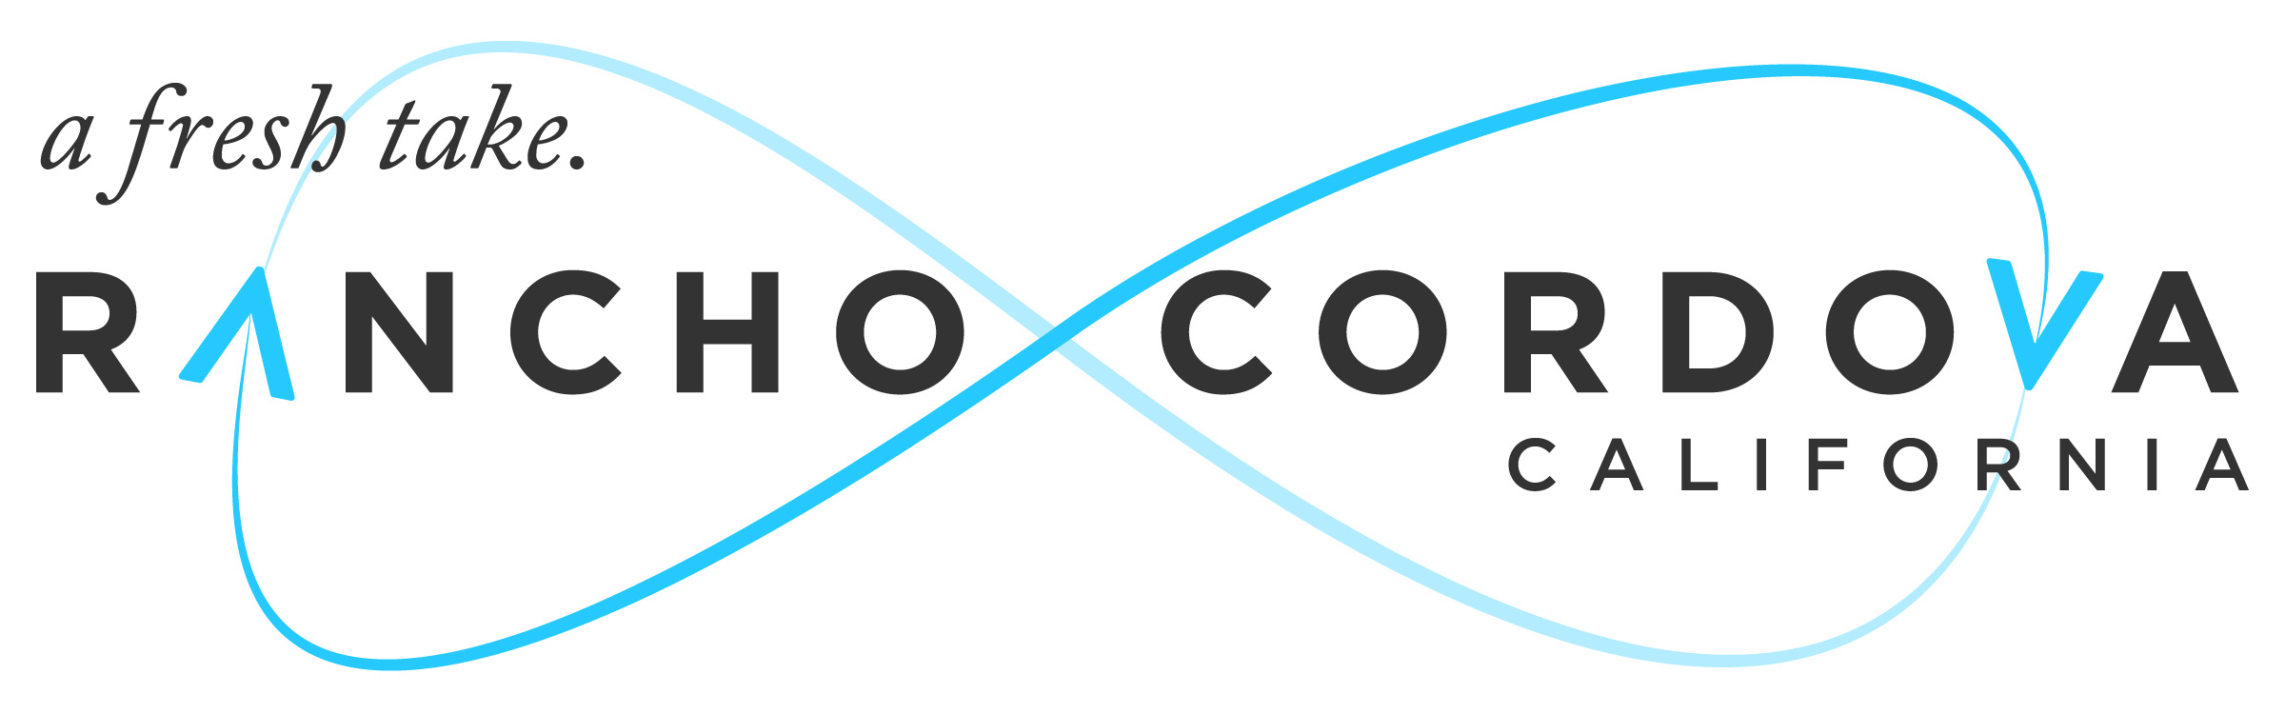

CONCURRENT MEETING

RANCHO CORDOVA CITY COUNCIL/
SUCCCESSOR AGENCY TO THE FORMER COMMUNITY
REDEVELOPMENT AGENCY (CRA)/
RANCHO CORDOVA FINANCING CORPORATION (RCFC)

2729 Prospect Park Drive, Rancho Cordova, CA 95670
5:30 P.M. – Regular Meeting

Monday, July 18, 2016

NOTICE OF CANCELLATION

The Monday, July 18, 2016 Regular Meeting of the City Council/Successor Agency to the Former Community Redevelopment Agency (CRA)/Rancho Cordova Financing Corporation (RCFC) is cancelled.

Certification of Posting of MEETING CANCELLATION

I, Mindy Cuppy, City Clerk for the City of Rancho Cordova, declare that the foregoing cancellation notice for the July 18, 2016 Regular Meeting of the Rancho Cordova City Council/Successor Agency to the CRA/RCFC was posted and available for review on Wednesday, July 13, 2016 at City Hall of the City of Rancho Cordova, 2729 Prospect Park Drive, Rancho Cordova, California, 95670.

Signed this 13th day of July, 2016 at Rancho Cordova, California.

